Daily Report

Department: Automobile Engineering Date: 24 March 2026

- Staff Attendance:

S. No | Dept. | Category | On Rolls | Absent | Details/Remarks
1 | Automobile Engineering | Teaching | 20 | 4 | Faculty – On Duty  - Dr. Shaik Amjad  - Dr. Shaik Aslam Ansari  Faculty – Casual / Earn Leave  a. Full Day  - Mr. Chandrashekhar B Banad (CL)  b. Half Day (FN/AN)  - Mr. MohamadAziz Athani (AN)  Faculty – Half Pay Leave  - Name of the Faculty  Faculty - Study Leave  - Name of the Faculty  Faculty - Maternity/Paternity Leave  - Name of the Faculty (ML/PL)  Leave Without Pay  Break in Service  1.
 |  | Non- Teaching | 07 | 1 | Staff– On Duty  1.  Staff- Casual / Earn Leave  a. Full Day  1. Mr. G. Karthik (CL)  b. Half Day (FN/AN)  Staff– Half Pay Leave  - Name of the Staff  Staff -Study Leave  1. Name of the Staff  Staff – Maternity/Paternity Leave  1.  Leave Without Pay

- Infrastructure issues or Maintenance:

S.No. | Description of the problem | Reported  On | Attended  On | Completed on | Remarks
1.

- Event (short term course / workshops/Seminar, etc.) organized:

S. No | Name of the Event-seminar/ short term course / workshops, etc. | Duration | For Whom | No. of Participants |  | Resource  Person/Faculty | Remarks
 |  |  |  | VNRVJIET | Others
1

- Participation by Staff:

S. No | Name | Event | Status (delegate /paper) Present, speaker) | Date and Duration

- Participation by Students:

S. No | Name | Event | Status (delegate /paper) Present, speaker) | Date and Duration
 | AVIDI GUNESHWAR VEERA DEVI KUMAR, Automobile Engineering & 24071A2408  B BHANU PRAKASH, Automobile Engineering & 25071A2406  RAVULA SUCHETHAN RAO, Automobile Engineering & 25071A2444 | PADMA BHUSHAN, DR. B. V. RAJU MEMORIAL NATIONAL LEVEL TOURNAMENT  These students won 1st place in Basketball Men, PADMA BHUSHAN, DR. B. V. RAJU MEMORIAL NATIONAL LEVEL TOURNAMENT, by B. V. Raju Institute of Technology, Vishnupur, Narsapur, Medak. | Completed | 23-24 March 2026

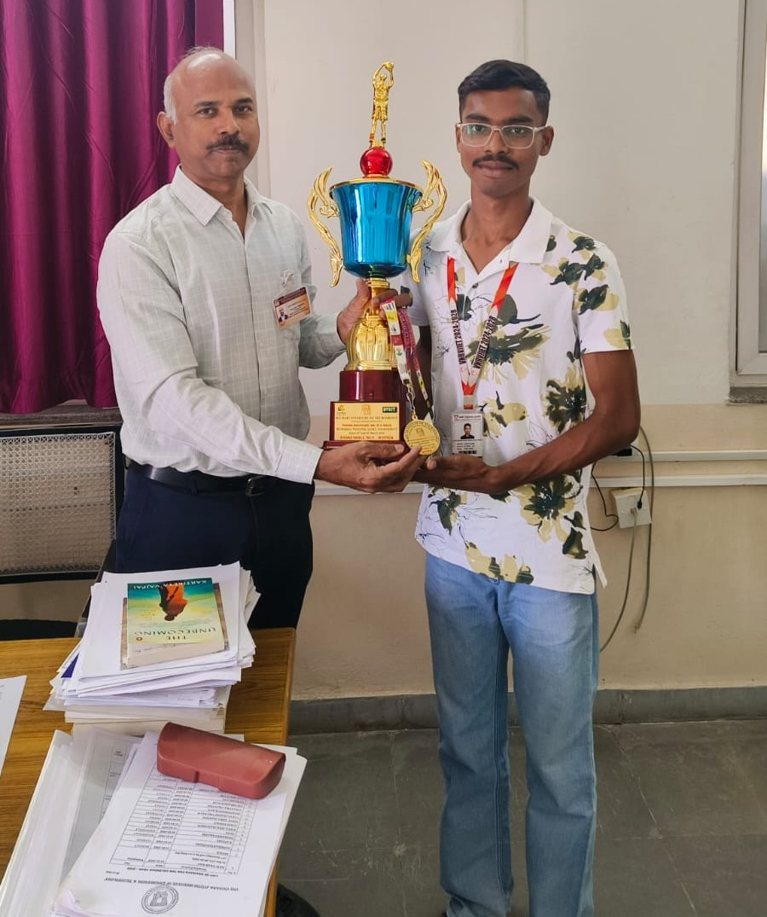

- Staff joined or left

S. No | Name of the Faculty | Designation | Date of Joining/leaving | Remarks

- Classwork Adjustment / Lectures Interchanged:

S. No | Dept | Subject | Time | Adjusted from | Adjusted to
1 | AE | Electric and Hybrid Vehicles | 10-11 a.m. | Dr. Shaik Amjad | Dr. GVL Prasad
2 | ECE-B | Engineering Drawing | 9-12Noon | Mr. Chandrashekhar B Banad | Mr. Vinay Kulkarni
3 | EEE-A | Engineering Drawing | 12.40-3.40 p.m. | Mr. Chandrashekhar B Banad | Mr. M. Vijay

- Incident if any (Discipline of staff or students, etc.)

S. No | Name | R. No. or ID No. | Brief statement | Remarks

- Any other matter to be reported:

HOD – AE

